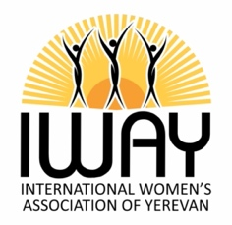
International Women’s Association of Yerevan (IWAY)
Application for Funding 2023-2024
(Email to iwaycharities@gmail.com )
Please complete the application in English or Armenian

Name of Applicant

Full Legal Name of Organization Applying for Funds

Address of Organization to Receive Funds

E-mail address | Contact Telephone
Title of project proposal

What is the main aim of the project?

Which segment of the community will the project serve? (E.g. the elderly/the young/unemployed/disabled/the poor?)

How many displaced families/individuals from Artsakh does the community host?

Give a rough indication of how many people you think this project will have a positive effect on.

Directly

Indirectly

Is this a new project?

If not, for how long has it been running?

How is it funded at present?

Is the IWAY funding intended to cover the entire project or only a portion of it?

If the request is for only a portion of the project, what other sources of funding are utilized?

What is the estimated time frame for completion of the project?

How much funding is required to see the project through to completion? (Proof of estimates may be required should the IWAY grant funding.)

Brief description of the project (including how the project will affect the community as a whole, i.e. the local and the displaced population from Artsakh)

What are the expected changes/outcomes/benefits/results expected by the end of the project?

How will the project, in particular the spending be monitored, and by whom?

How will the project be maintained after completion?

Any other comments

Signature Date:

Email the completed form to iwaycharities@gmail.com

